**UNHCR – CloudERP Generator Data Update Survey**

To access the survey, navigate to the link provided (<https://enketo.unhcr.org/x/6ouKSxeK>).

You will be presented with a welcome screen. You can select the language of the survey using the dropdown button on the top of the screen.

Begin by selecting your region, country and location. Note:

* Some cities have more than one location; please complete the survey once for each location (e.g. Georgetown Office, Georgetown Warehouse).
* Contact the survey sender if you do not see your location in the list.

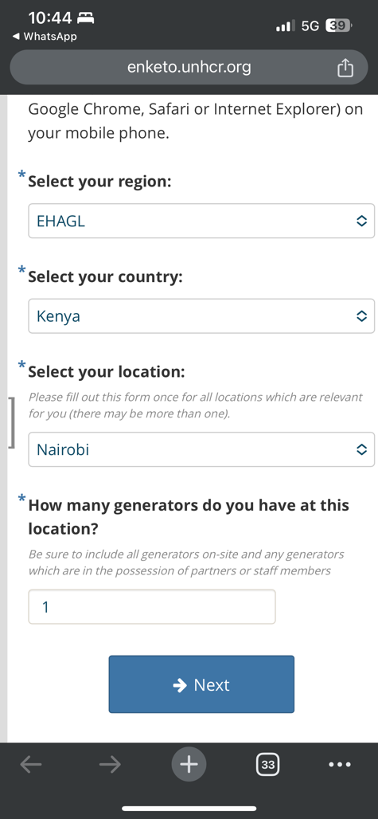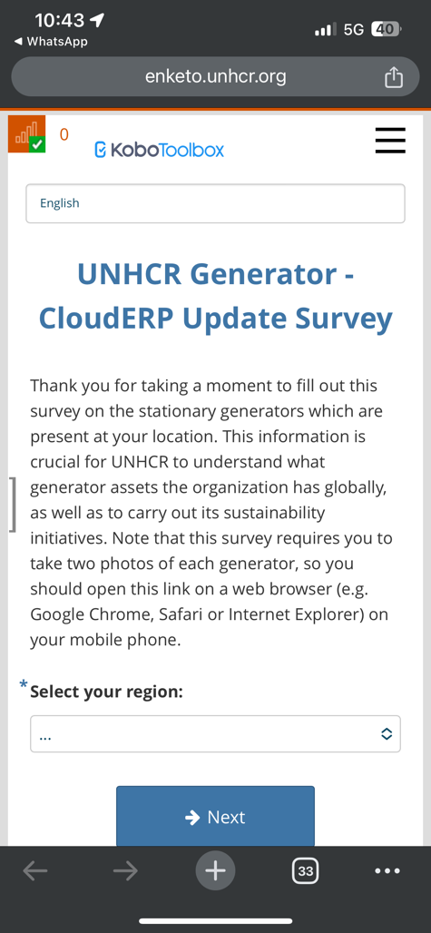Next, indicate the number of generators that are present at your location, then tap “Next”.

Next, fill in the series of questions regarding each generator. You will be presented with the same set of questions for each generator; the small number on the top right indicates which generator you are reporting.

When you tap to provide a photo, you will be directed to either take a picture of the generator or upload a saved photo.

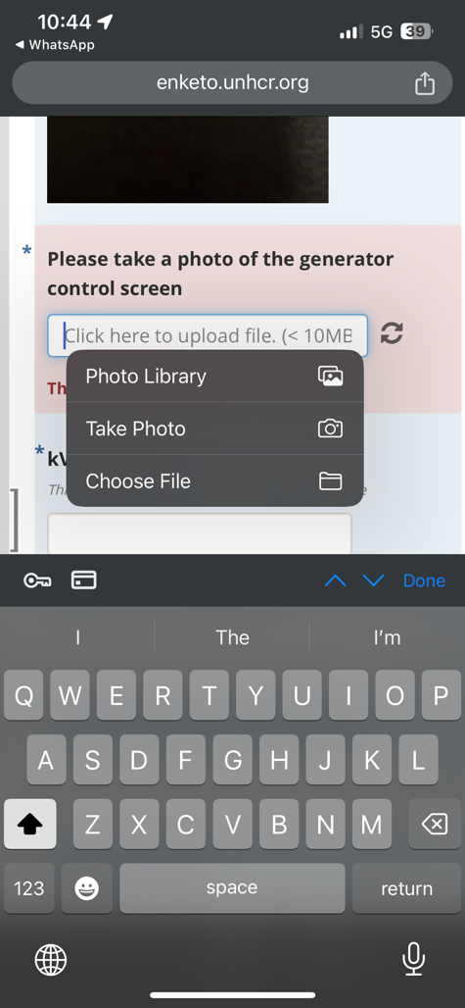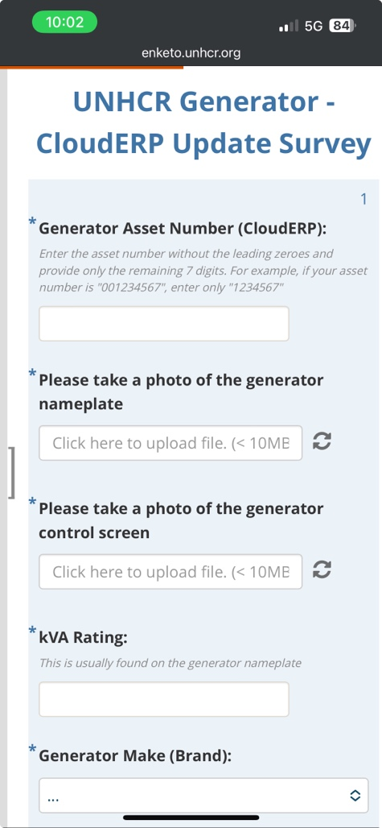

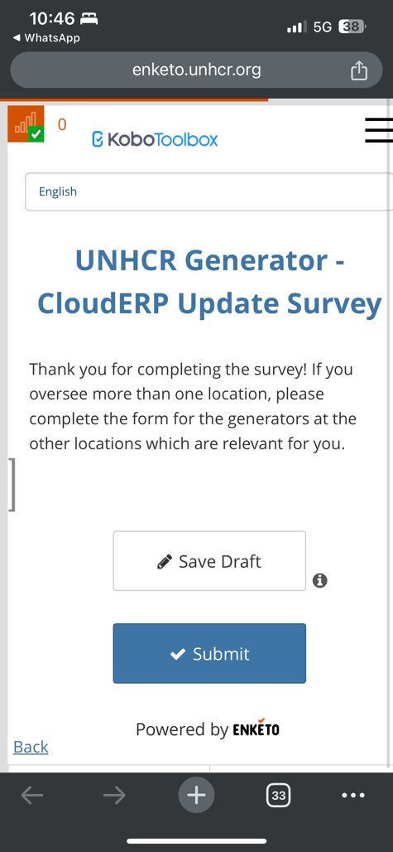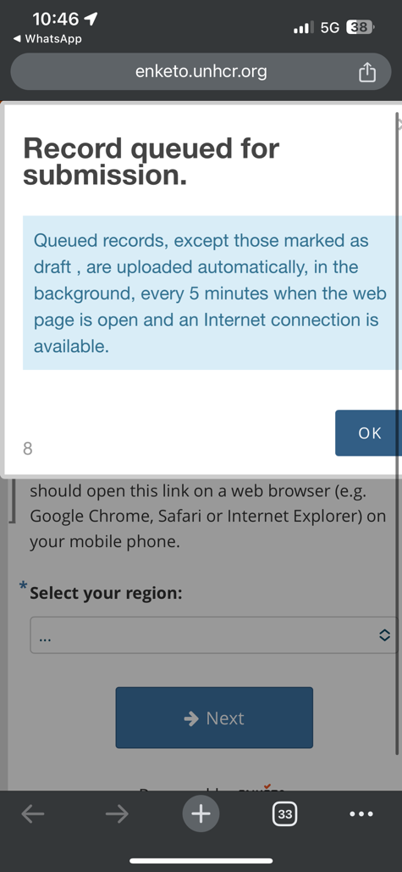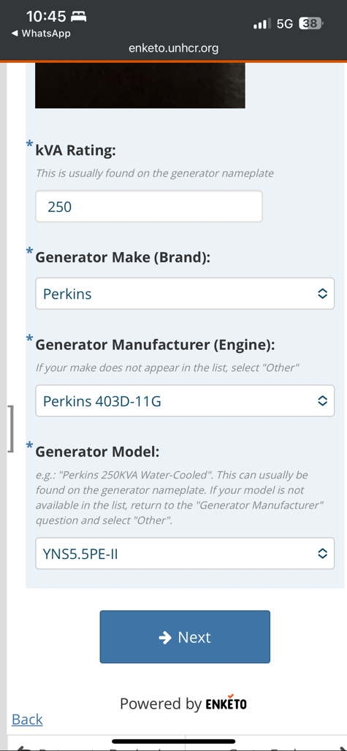Once you have completed all of the relevant information for the generator, tap “Next”, then “Submit”. You may see a message stating that your record has been queued for submission.

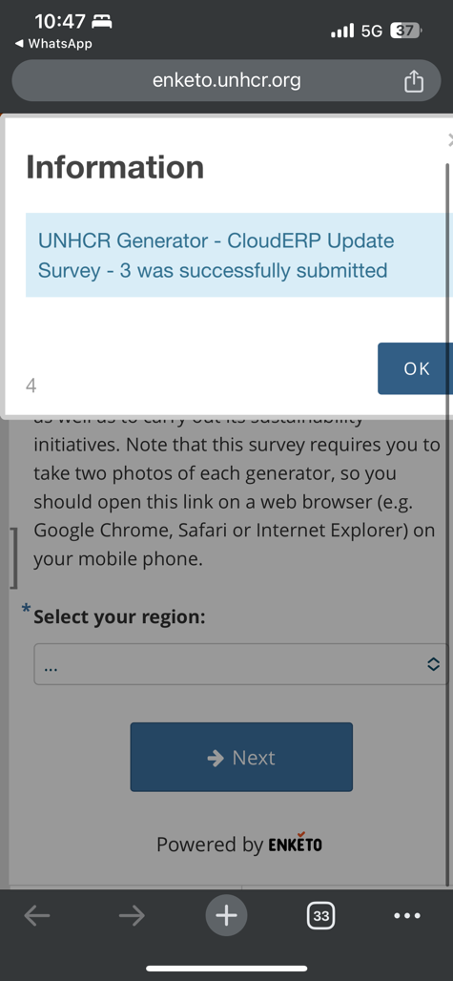**Important:** Leave the page open for a few seconds until the record submits. You will know the record has submitted when a message appears like the one below.